1. Project Overview
- Grade Range Prediction: Classifying a student's grade range in a specific subject based on their previous performance.
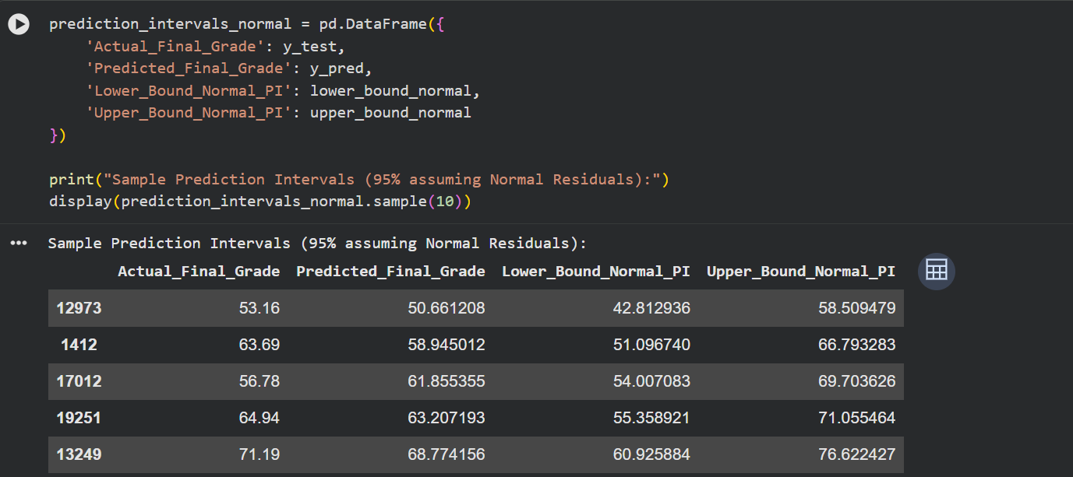
- Course Recommendation System: Determining the most suitable courses for the student in the upcoming semester to ensure the best performance.
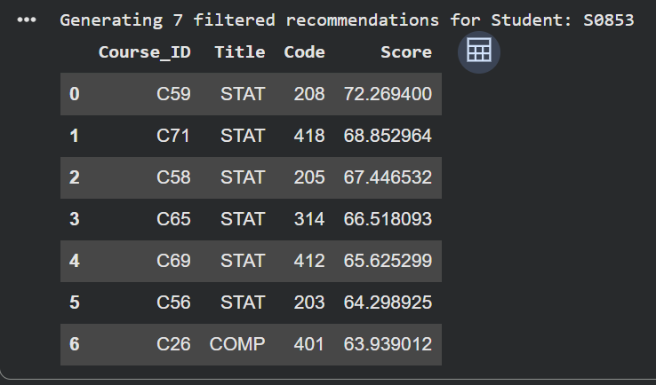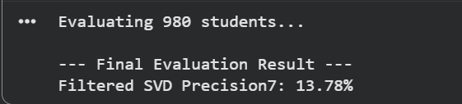

Final GPA Prediction
Three separate models were developed to predict a student’s final GPA upon graduation, each customized based on the student's current level (Sophomore, Junior, or Senior):
- Model A (Sophomore Level): Targets second-year students; it predicts the final GPA based on first-year results only.
- Model B (Junior Level): Targets third-year students; it predicts the final GPA based on the results of both the first and second years to increase prediction accuracy.
- Model C (Senior Level): Targets students at the beginning of their fourth year; it uses the full academic record of the three previous years (first, second, and third) to provide the most accurate final GPA prediction

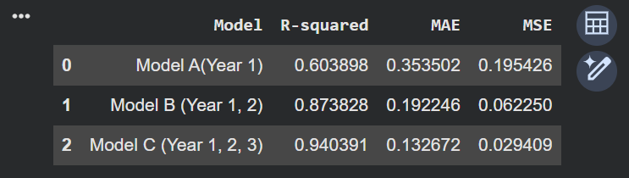

2. Model Development

Grade Range Prediction
Feature Selection: The following features were selected based on their direct correlation with the student's final result:
- Percentage of Coursework_Grade: Represents the student's performance in periodic tests and assignments.
- Weekly Attendance: Reflects the student's level of commitment and interaction with the subject.
- Target: Predicting the Percentage of Final_Grade.
Processing:
- Ensured that all inputs are numerical values.
- Performed Correlation Analysis to confirm that the selected columns have a strong statistical impact on the target.

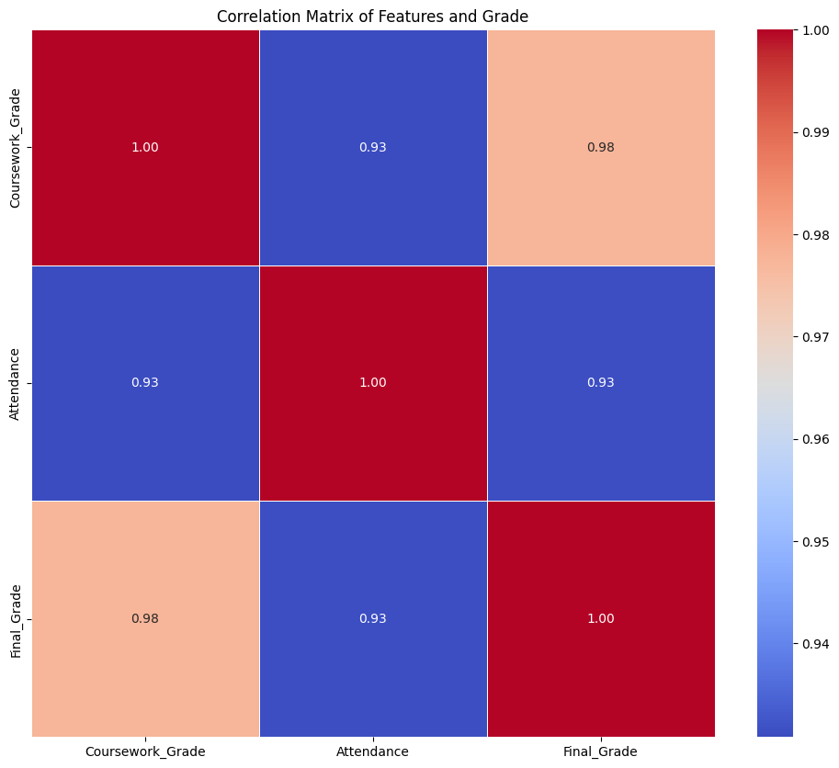

Model Selection and Experiments
In the development phase, several approaches were tested to achieve the best results:
- Decision Tree: Initially, a Decision Tree model was tested, but it resulted in very low accuracy. The model was unable to capture the relationship between the features effectively (Underfitting), so it was replaced by a more suitable model.
- Bootstrapping: A Bootstrapping technique was also tested for calculating confidence intervals. However, it was replaced by a Statistical Formula (Normal Distribution of Residuals) because:
  - Computational Time: Bootstrapping was time-consuming.
  - Efficiency: The statistical formula gave similar results much faster, making it more efficient for the system's overall performance.

Final Model Selection
Model: Multiple Linear Regression After testing various approaches, Linear Regression was selected as the final model for this task.
Rationale (Reason for Selection):
- Linear Relationship: The relationship between coursework grades, attendance, and final grades is naturally linear, making this model highly effective.
- Mathematical Precision: By using the Standard Deviation of Residuals, we were able to calculate a 95% Confidence Interval (Margin of Error) to provide a range for the student's grade rather than just a single point.
Implementation Details: The model calculates the margin of error using the formula:
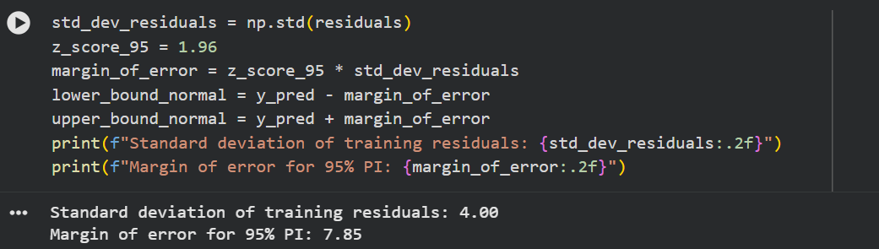
This ensures that the predicted grade range is statistically sound and accounts for the typical variance found in the training data.

2.2 Course Recommendation System
A. Methodology: The system is designed to suggest the most suitable courses for students using Collaborative Filtering. We transitioned through several experiments to overcome the challenge of sparse data.
B. Experiments & Model Evolution:
- First Experiment (Similarity Matrix): Initially, we used a traditional User-Item Similarity Matrix. However, the accuracy was very low due to the High Sparsity of the dataset (a large number of NaN values), as most students had only taken a small fraction of the available courses.
- Second Experiment (Hybrid Approach): To fill the gaps, we used the Course Grade Prediction Model (from the previous section) to predict some of the missing grades before calculating similarities. While the accuracy improved slightly, the system remained computationally heavy and lacked the desired precision.
- Final Approach (Matrix Factorization - SVD): The final and most successful model uses Singular Value Decomposition (SVD). This method is specifically designed to handle sparse matrices by decomposing the user-item matrix into latent factors.
C. Implementation Details (The Final Model):
- Mean Centering: We performed Mean Centering by subtracting each student's average grade from their records to normalize the data and account for different grading styles.
- SVD Algorithm: We applied svds with k_factors = 50 to capture hidden patterns between students' academic behavior and course characteristics.
- Recommendation Strategy: The model reconstructs the matrix to provide predicted grades for all remaining courses. The system then recommends the courses where the student is predicted to achieve the highest performance.

Filtering (Post-processing)
After generating predicted scores using SVD, a specialized filtering function get_svd_recommendations_filtered was implemented to ensure the recommendations are academic-compliant. The system filters candidates based on:
- Exclusion of Taken Courses: Courses that the student has already completed are removed.
- Prerequisite Verification: The system checks the prerequisites_df to ensure the student has passed all required courses (Grade >= 50) before recommending a more advanced one.
- Top-K Recommendations: Only the top 7 courses with the highest predicted scores that meet all conditions are presented to the student.
- Code:
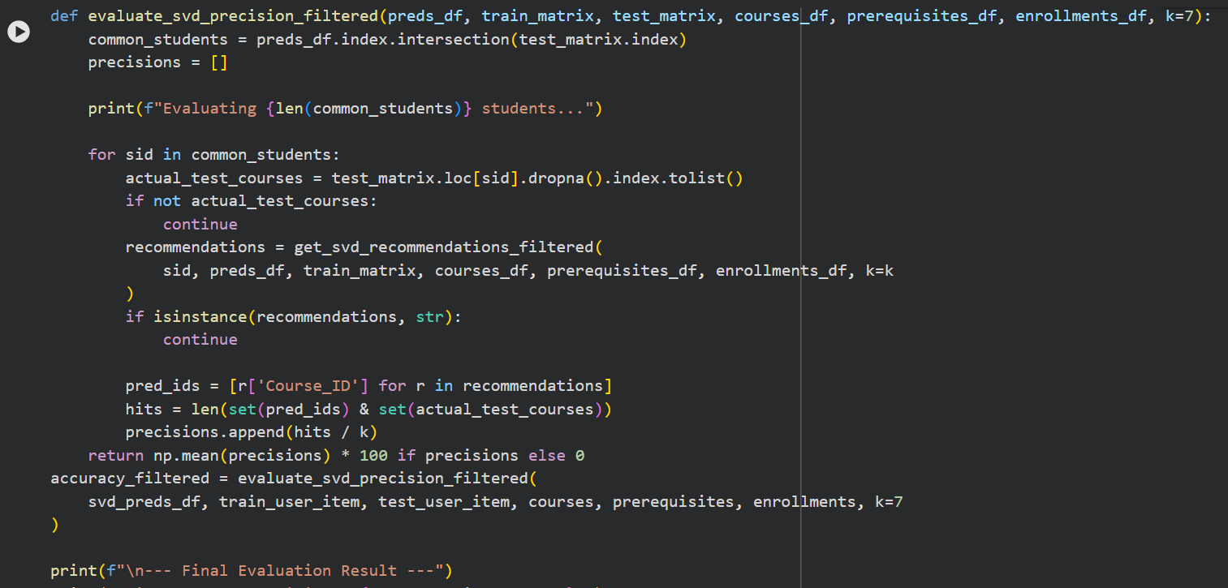

Model Evaluation (Precision@K)
To measure the effectiveness of the recommendation system, we used the Precision at K (Precision@7) metric.
- Evaluation Logic: For each student in the test set, the system generates 7 recommendations and compares them with the actual courses the student chose in reality (Test Set).
- Hit Calculation: A "Hit" is counted if a recommended course matches an actual course taken by the student.
- Final Result: The precision is calculated as the average percentage of "Hits" across all students.
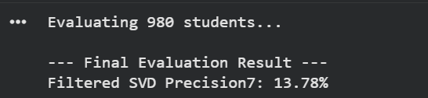
D. Why SVD? (Rationale):
- Handling Sparsity: SVD effectively deals with NaN values by uncovering "latent factors" rather than relying on direct matches.
- Scalability: It is much faster and more efficient for the Backend API compared to calculating a full similarity matrix.

2.3 Final GPA Prediction Models
A. Data Generation & Characteristics: To develop a robust prediction system, a dataset of 500 students was synthesized using statistical distributions that mimic real-world academic progression:
- GPA Progression: Each year's GPA is linked to the previous one with a controlled "random noise," ensuring a logical correlation between levels.
- Weighted Target: The Final_GPA_Target was calculated using a weighted formula where later years (Year 3) have a higher impact (0.7) on the final result, reflecting the reality of cumulative GPAs.
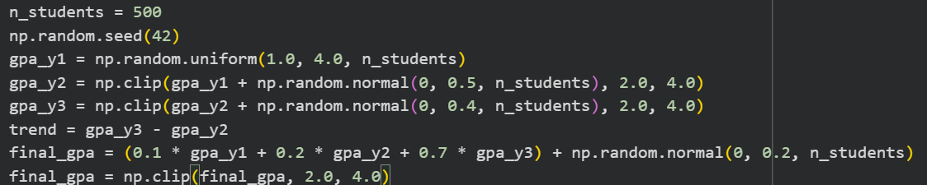
Multi-Level Modeling Strategy: Instead of a single model, we developed three specialized models to provide predictions at different stages of the student's journey:
- Model A (Sophomore Level):
  - Input: GPA Year 1.
  - Goal: Early prediction for second-year students.
  - Evaluation:
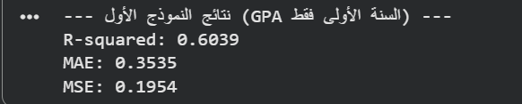
- Model B (Junior Level):
  - Inputs: GPA Year 1 + GPA Year 2.
  - Goal: Improved accuracy for third-year students.
  - Goal: Early prediction for second-year students.
  - Evaluation:
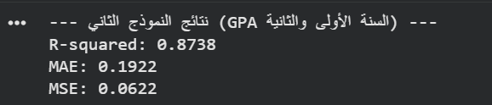
- Model C (Senior Level):
  - Inputs: GPA Year 1 + GPA Year 2 + GPA Year 3.
  - Goal: The most precise prediction for students entering their final year.
  - Evaluation:
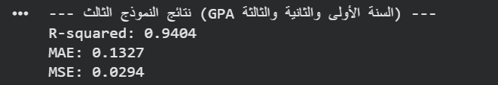
Implementation & Validation:
- Algorithm: Linear Regression was used for all three models due to the strong linear relationship between yearly GPAs and the final cumulative GPA.
- Data Splitting: Each model was trained and tested using an 80/20 split to ensure the accuracy results are reliable and not overfitted.

3. Model Deployment & Backend Integration
To integrate the trained models with the system's Backend, we followed a professional deployment pipeline:

A. Model Serialization (Saving the Models)
Once the models reached the desired accuracy, we exported them into permanent files to be loaded by the server without needing to re-train.
- Pickle: We used pickle to save the Linear Regression and SVD models as binary files (e.g., grade_model.pkl, svd_model.pkl).
- Data Objects: Along with the models, we exported necessary data structures like the Student_Means and Course_Mapping dictionaries to ensure consistent preprocessing in the backend
- Code Example:
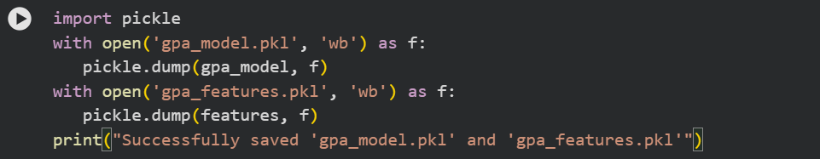

4. Technical Stack & Dependencies
To ensure the scalability and efficiency of the project, we utilized a set of industry-standard Python libraries. Below is a list of the core technologies used:

A. Data Manipulation & Analysis
- Pandas: Used for data cleaning, manipulation, and creating the User-Item matrix for the recommendation system.
- NumPy: Essential for numerical computations, handling arrays, and performing statistical operations (like Standard Deviation and Z-scores).

B. Machine Learning & Algorithms
- Scikit-Learn: The primary library for implementing the Linear Regression models, performing Train-Test Splits, and calculating evaluation metrics (MAE, R²).
- SciPy: Specifically the scipy.sparse and svds modules, used for handling large sparse matrices and executing the Singular Value Decomposition (SVD).

C. Deployment & Integration
- Pickle: Used for Model Serialization, allowing us to save trained models and reload them efficiently in the production environment.

D. Data Visualization
- Matplotlib / Seaborn: Used during the exploratory data analysis (EDA) phase to visualize correlations and grade distributions.

